Master Db2 pureScale Installation : A Streamlined GUI Walkthrough for Linux/AIX

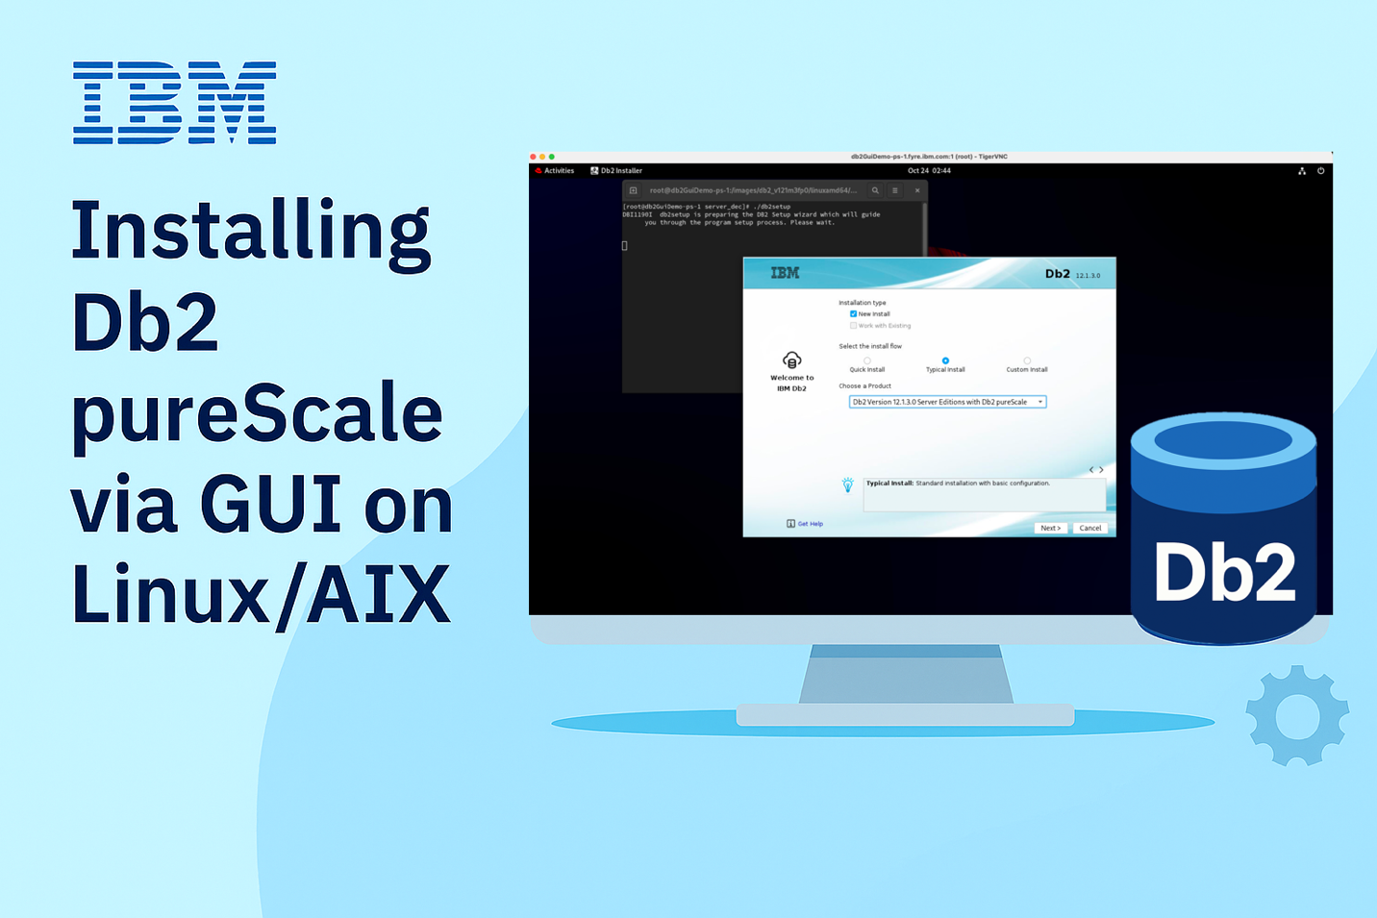

## Db2 pureScale Setup – Where High-Availability meets unstoppable Scalability

Db2 pureScale is IBM’s answer to uninterrupted performance and seamless scalability, turning your database into a fault-tolerant, multi-node powerhouse built for the most demanding enterprise workloads. In simple terms, this is a database that refuses to go down – even during peak traffic surges or hardware hiccups.

Worried about the setup? Don’t be. If you're working on a Linux/AIX environment and prefer a graphical interface, this guide will walk you through the installation using the Db2 GUI installer—complete with visuals and practical tips.

Whether you're a seasoned Db2 admin or a curious developer, this blog walkthrough will help you get your pureScale cluster up and running smoothly.

## Step-by-step Installation Walkthrough

### Kick-off the GUI Installer

Start by launching the *db2setup* utility from the extracted Db2 installation image via your desktop environment.

**Tip:** Need the Db2 installation image? Not sure about the environment setup or what pre-requisites you need? Don’t worry – we’ve got you covered. Just head to the Wrapping-Up section at the end of this blog for all the details.

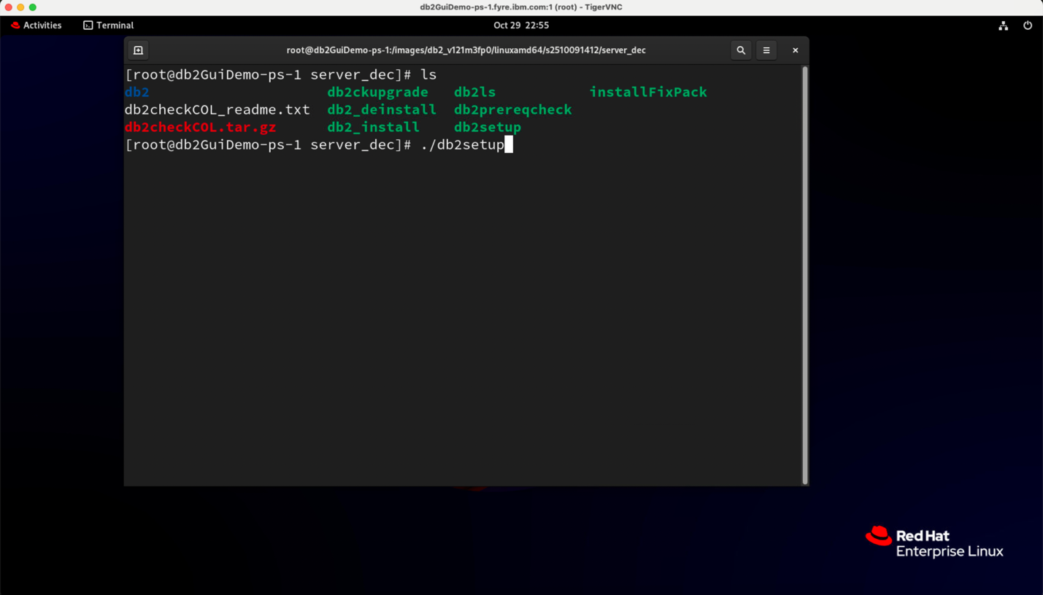

### Say Yes to the License terms

Before diving in, take a moment to review the IBM and non-IBM license agreements. Once you’re ready, click the *I agree* radio button to move to the next step.

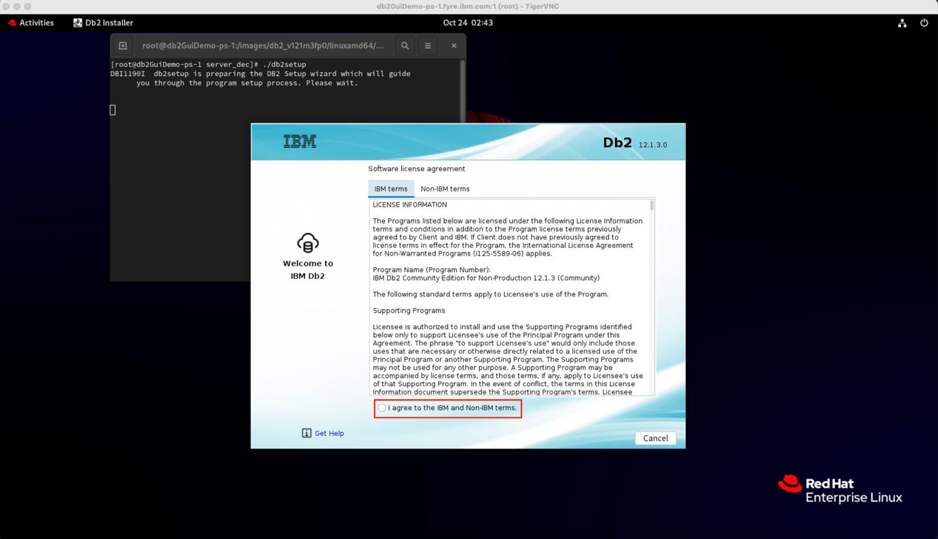

### The Easy Route - Typical Install

On the Installation type screen, choose *Typical Install* as the install flow – it’s the easiest way to get started without unnecessary complexity. From the product drop-down, select *Db2 Server Edition with Db2 pureScale* to enable clustering features. Hit *Next* to get started on your pureScale setup journey.

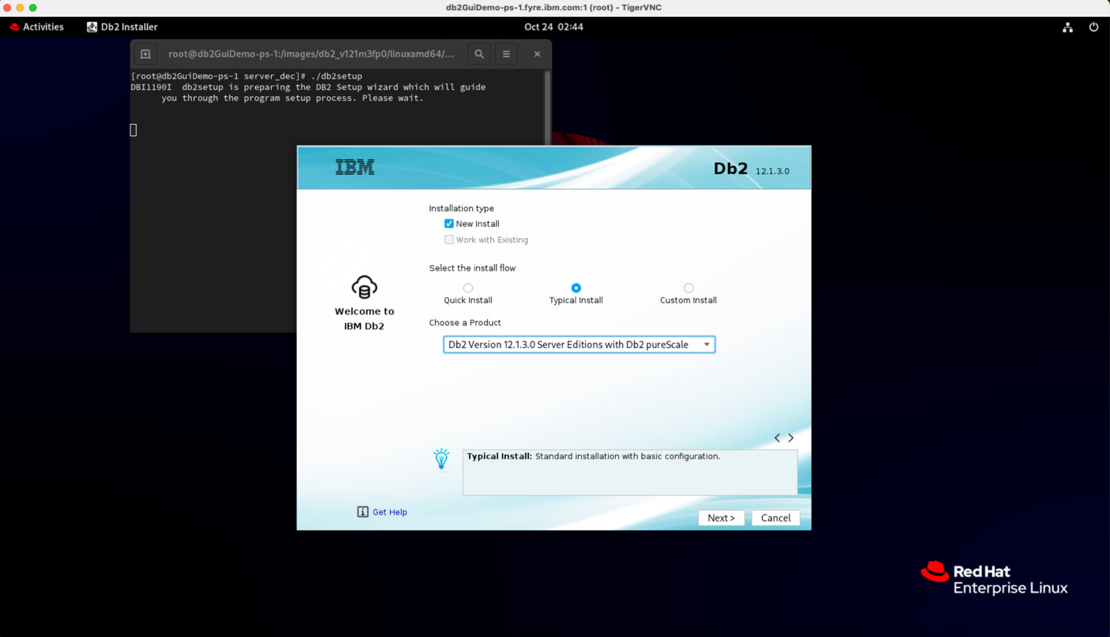

### Set the stage – Choose your installation path

You can stick with the installation path pre-filled by the installer or customize it If necessary.

**Tip:** Make sure ***“Create an instance”*** option is selected - this saves you from manual configuration later.

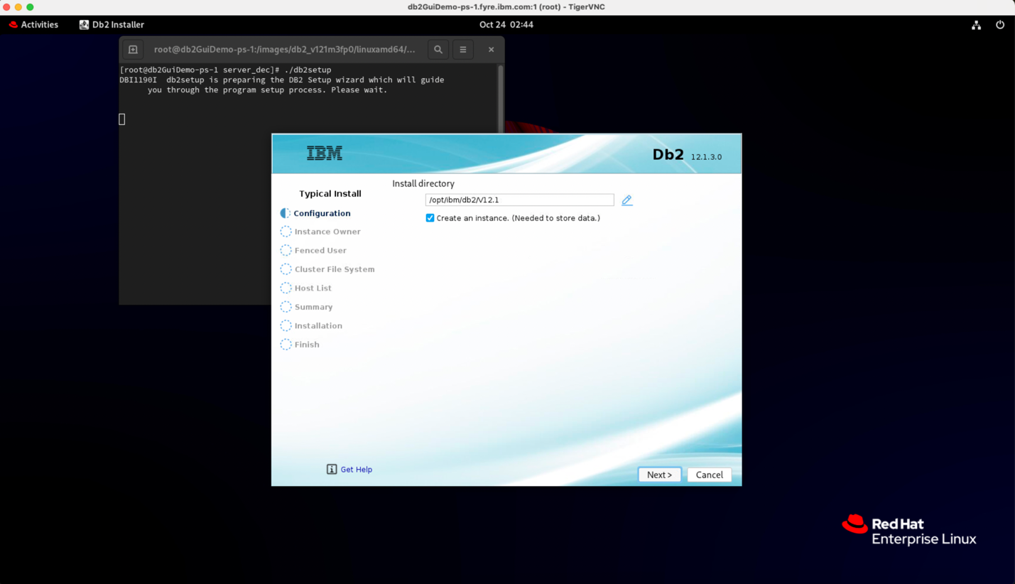

### Define who runs the show – Instance Owner Configuration

**Time to set up the boss of your Db2 instance – the primary administrator for your Db2 environment.**

The installer will pre-fill details like username, group name, and home directory for you. (Modify these if necessary). Just add a strong password and you are good to go. Hit *Next*.

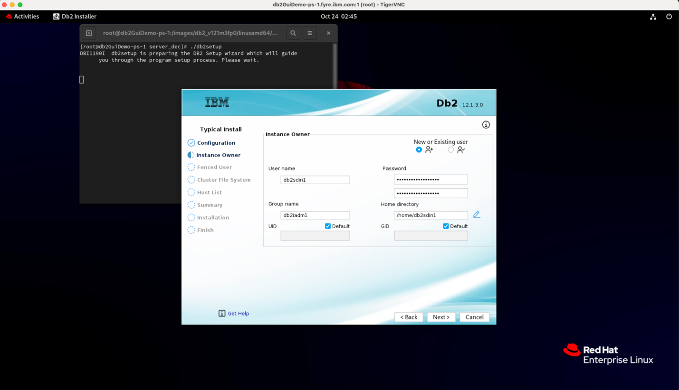

### Protect your instance - Fenced User Configuration

Now it’s time to setup the fenced user – the safety net for your Db2 instance.

As in the previous step, adjust any installer pre-filled values if necessary, add a strong password and click *Next* to proceed.

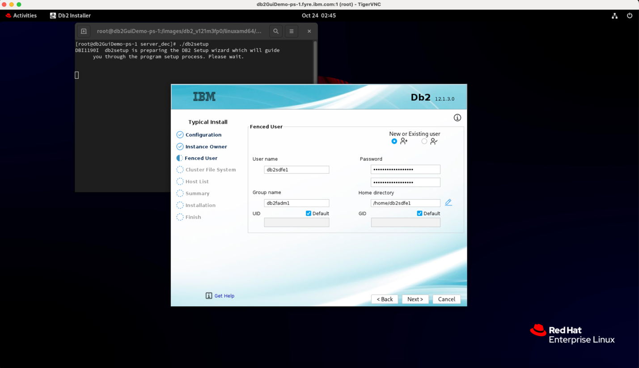

### Laying the Foundation – Cluster File System

Point Db2 to its shared storage hub. Enter the path for your shared disk partition device—the backbone of your cluster’s data. The installer will pre-fill Mount Point, Mount Point (Data) and Mount point (Log). Modify them if necessary and click *Next* to proceed.

**Note:** If you’re on AIX, you’ll also see the *Tiebreaker Device path* option. Make sure to specify it correctly. This option is hidden for Linux users.

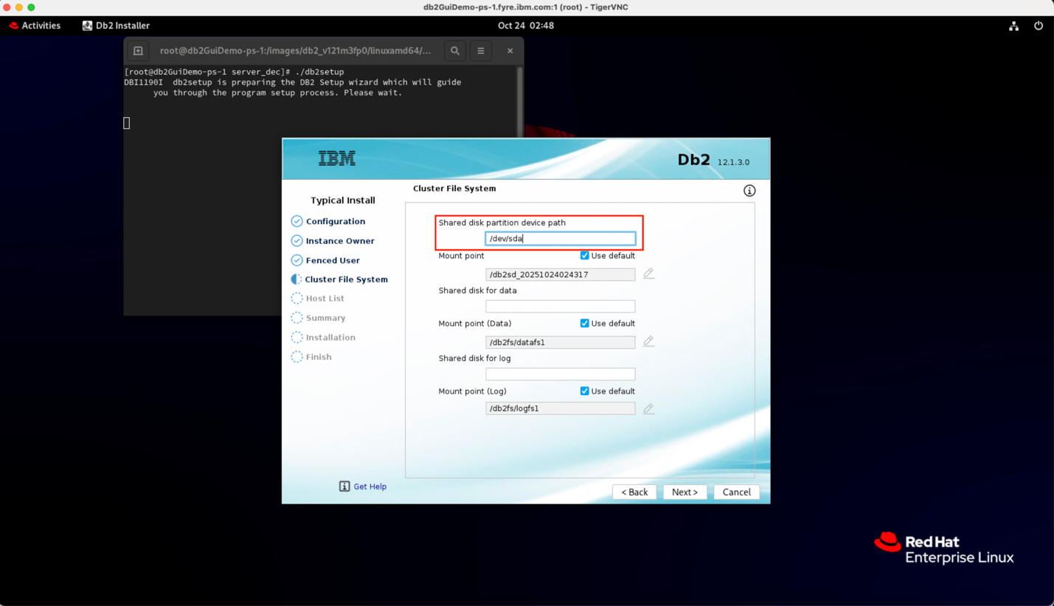

### Build your Cluster – Add the Hosts

On the Host List screen, click *Add* to start adding cluster hosts.

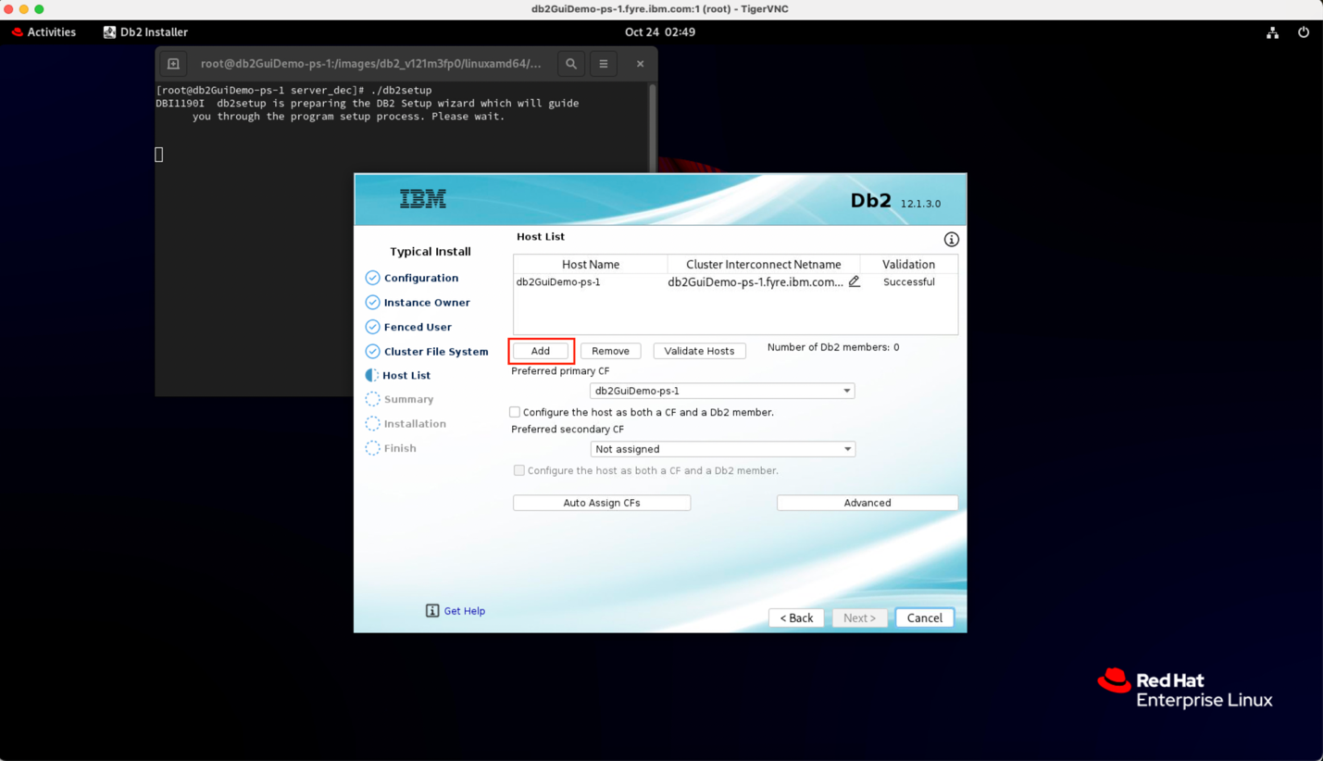

### Specify Remote Hostname

Enter the hostname of the new machine and click *Add* to include it in the cluster host list.

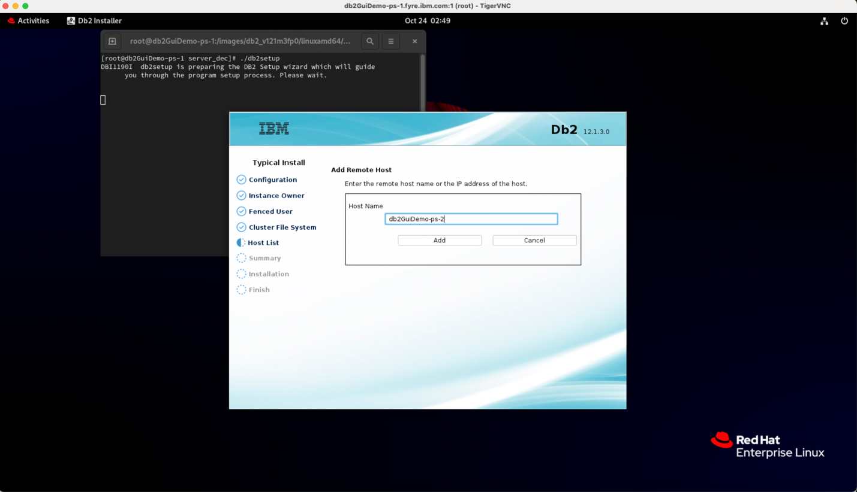

### Add more hosts

Repeat the same steps for each additional host until your cluster host list is complete.

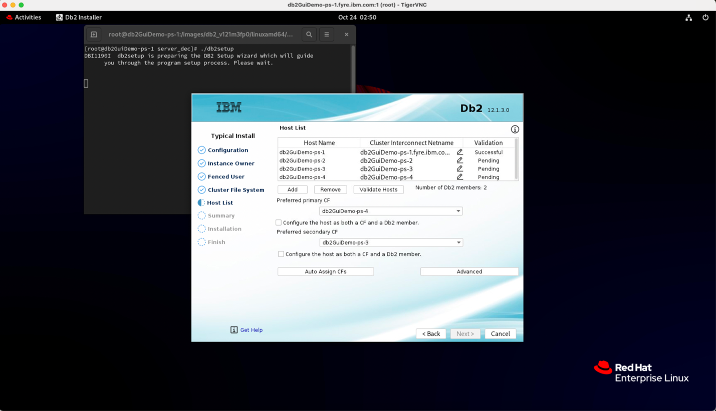**Note:** For a balanced and resilient cluster, it’s recommended to include at least 4 hosts – configured as 2 Members and 2 Cluster Caching Facilities (CFs).

### Host Validation – Make sure every Node connects

Once your host list is ready, hit ***Validate Hosts***.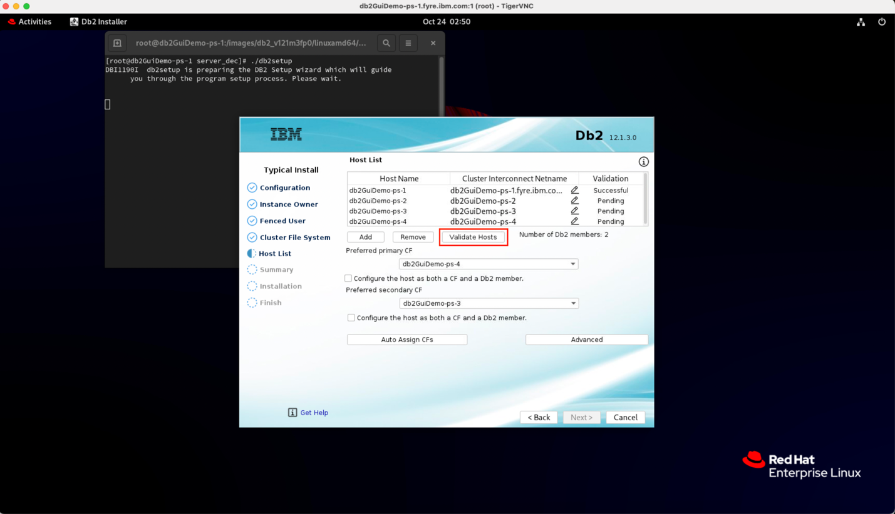

### Validation in action

Sit back and wait as the installer runs some checks to make sure every machine is reachable and ready to join the party.

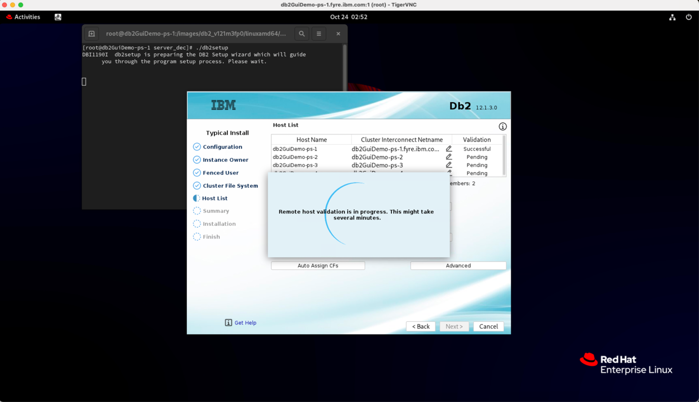

### Confirm Successful Validation

Ensure the Validation column shows successful for all the listed hosts.

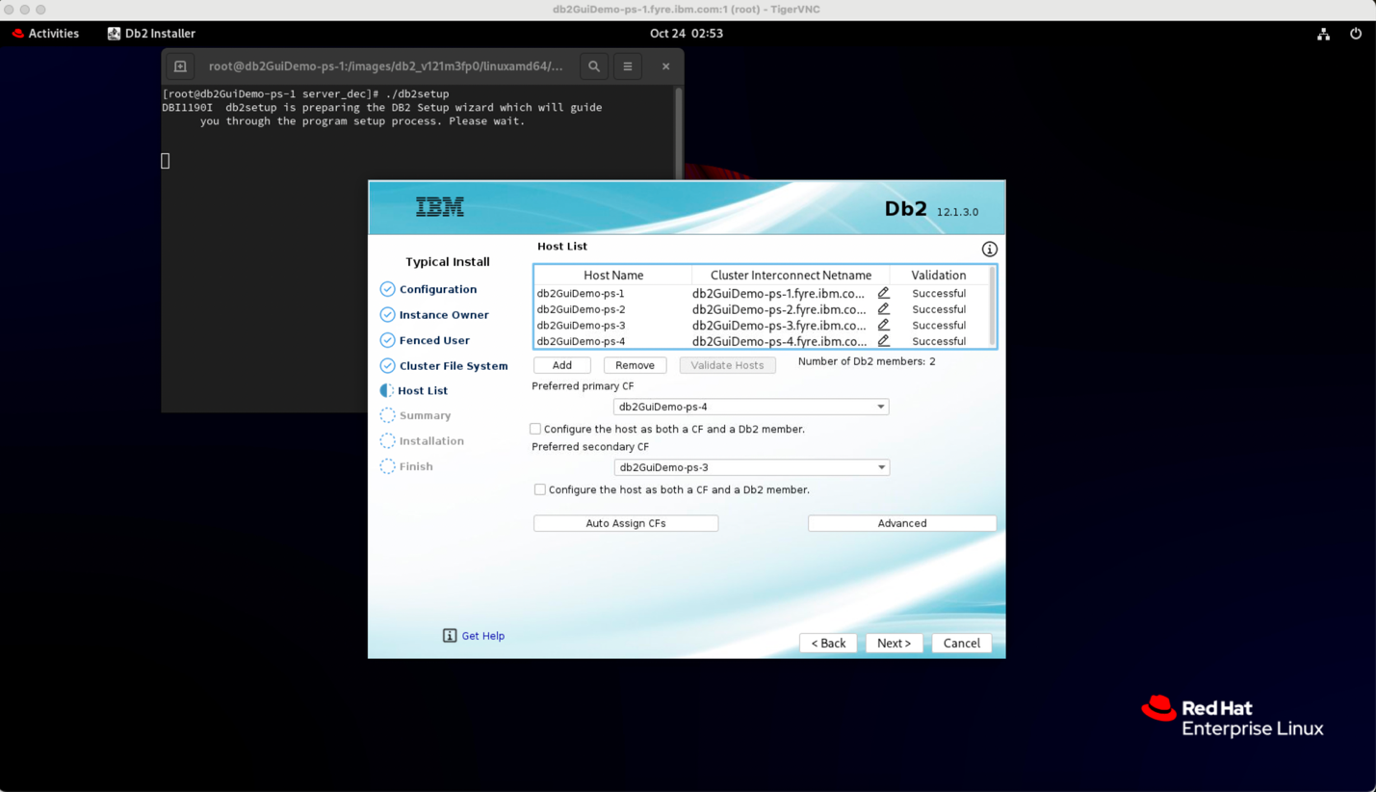

### Final prep – Prerequisite Checks

Once every host in your cluster host list passes validation, hit *Next* to let the installer perform its pre-requisite checks.

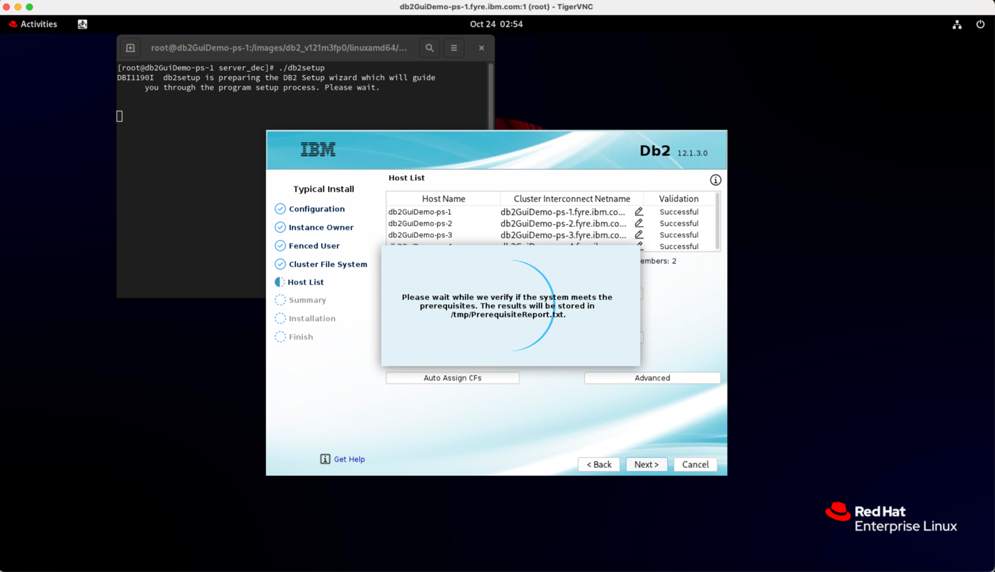

### Ready to Go – Start your installation

Once the prerequisite checks pass, you’ll land on the Summary screen. Confirm that the option 'Install on this computer and save my settings in a response file' is selected. Click *Install* to start the Db2 pureScale installation.

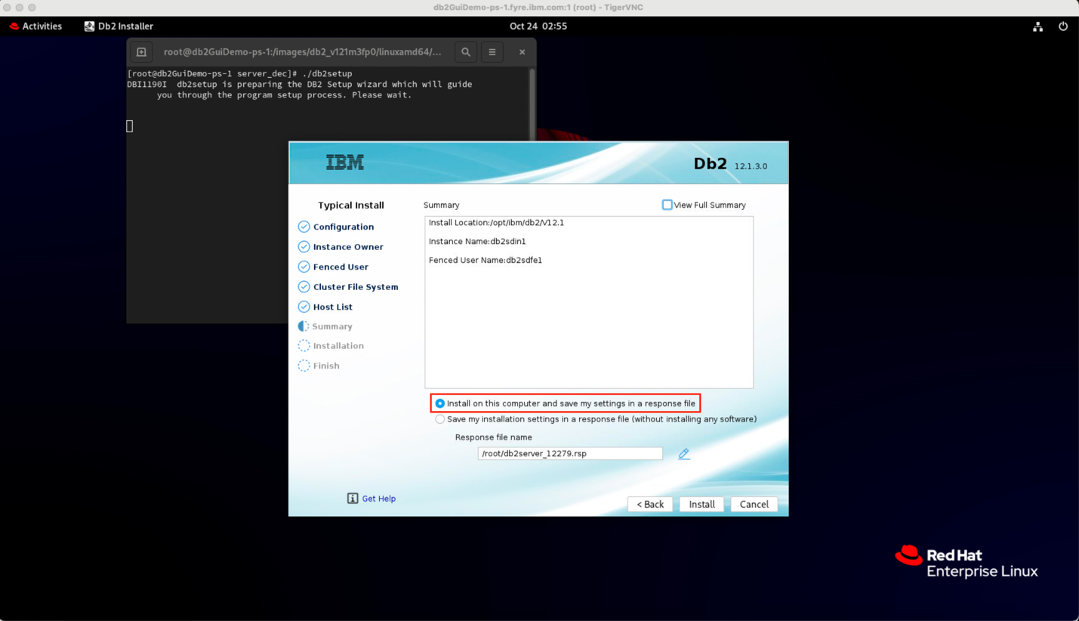

### Installing.... Almost there!

Sit back and watch the progress as Db2 pureScale installs.

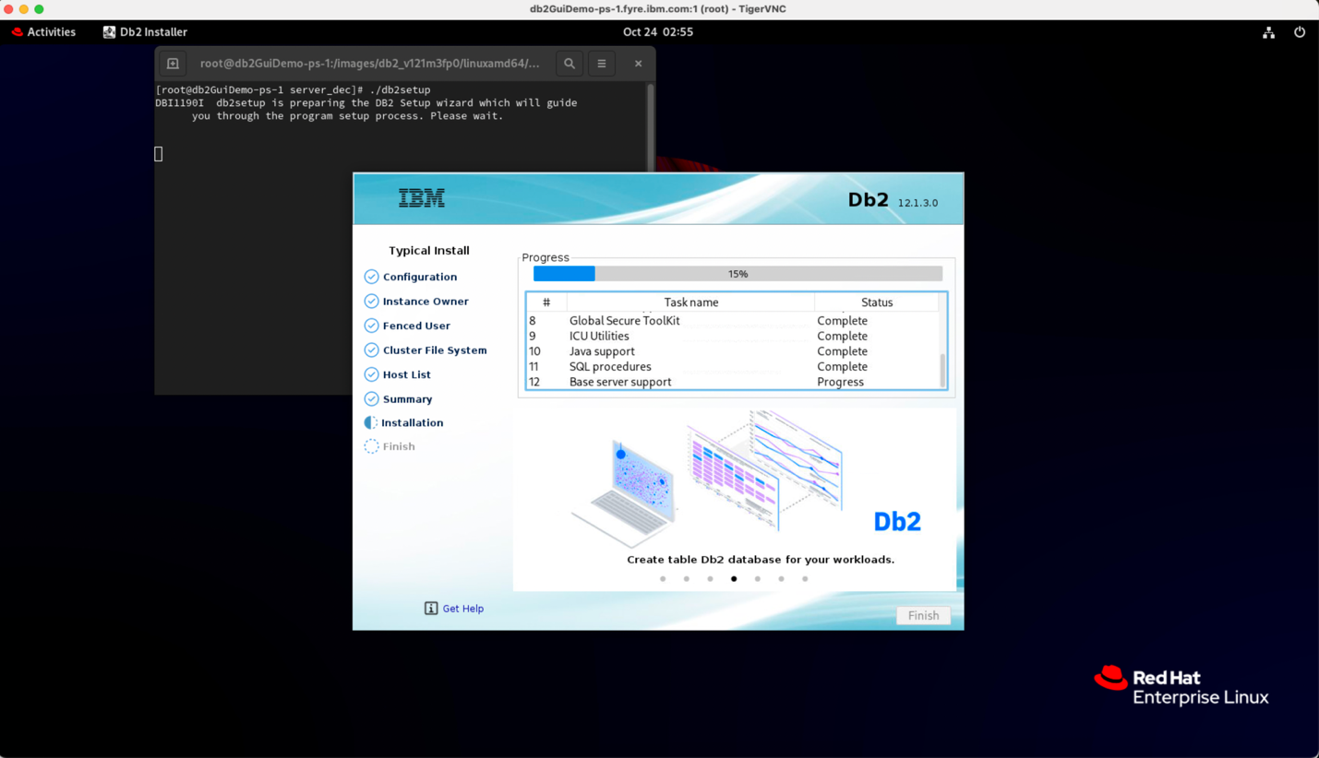

### That’s it.... You’re all Set!

Once the installation is successful, click *Finish* to finalize the setup and begin using Db2 pureScale.

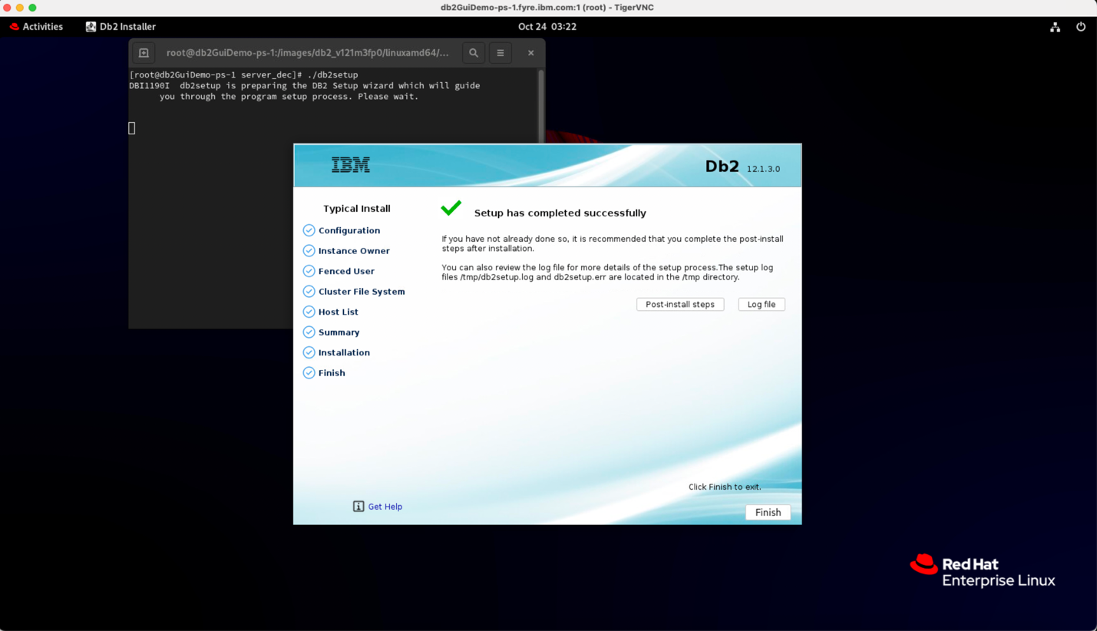

## Wrapping-Up – Few Handy Links & Tips

### Get started with Db2 Community Edition

New to Db2 and not sure where to begin? The [Db2 Community Edition](https://www.ibm.com/products/db2/get-started#Download+Db2+Community+Edition) is a great starting point for your Db2 journey—free, feature-rich, and beginner-friendly.

### Setup the pureScale environment

Checkout the official IBM documentation on [Installing a Db2 pureScale environment](https://www.ibm.com/docs/en/db2/12.1.x?topic=installing-db2-purescale-environment) to ensure your environment is properly setup across all the participating machines.

### Want to dive deeper into Db2 pureScale?

Checkout the official IBM documentation on [Introduction to a Db2 pureScale environment](https://www.ibm.com/docs/en/db2/12.1.0?topic=editions-introduction-db2-purescale-environment) . It’s a great starting point for understanding the architecture, components, and key features.

### Need help troubleshooting?

Checkout the official IBM documentation on [Troubleshooting the Db2 pureScale Feature](https://www.ibm.com/docs/en/db2/12.1.0?topic=techniques-troubleshooting-db2-purescale-feature) . It’s packed with practical guidance—covering problem diagnosis, FAQs on host validation, instance rollback, and more—to keep your cluster running smoothly.

### Optimize your GUI installer experience

For the best visual experience, use a high desktop resolution when working with the Db2 GUI installer. All screenshots in this blog were captured via [TigerVNC](https://tigervnc.org/) on a Mac, connected to a RHEL 9.6 server running GNOME desktop. VNC server resolution of 2000×1200 delivered excellent clarity on this setup. Lower resolution like 800×600 can distort interface elements and give you a less polished experience. Also, make sure you’re on Db2 version 12.1.3 or later to enjoy the modernized GUI installer.

### Root Access required

Db2 pureScale requires root access - so ensure that all the installation steps are executed as root user.

## About the Authors

Aslam Nomani is a Senior Technical Staff Member and Senior Manager within the Db2 Development team. He currently leads a team focused on modernization and the exploitation of Generative AI. Aslam has been with the Db2 team in the IBM Toronto Lab for over 25 years and has a BSc in Computer Science and a BSc in Commerce. His focus areas in the past have been around Quality Assurance and delivering Continuously Available solutions.

Ehab Islam is an Automation Developer and QA Tester at IBM Canada Software Lab, specializing in Db2 pureScale testing and automation. He has contributed to improving Db2 quality by developing automation frameworks and collaborating closely with development teams to identify and resolve software defects. Ehab is very passionate about driving efficiency and innovation through automation.

Safa N is a Software Developer at IBM, working with the Db2 Deployment team in Kochi, Kerala. She plays an active role in improving the deployment flow as part of each release cycle and drives automation efforts to streamline repetitive development tasks, helping accelerate code delivery. She’s passionate about learning new things and enjoys exploring emerging technologies with curiosity and enthusiasm.